1.

include <stdio.h>

int main() {
int marks[2][3];
int total, highest, lowest;
float average;

// Input marks for 2 students
for (int i = 0; i < 2; i++) {
printf("Enter marks of 3 subjects for Student %d:
", i + 1);
for (int j = 0; j < 3; j++) {
printf("Subject %d: ", j + 1);
scanf("%d", &marks[i][j]);
}
}
for (int i = 0; i < 2; i++) {
total = 0;
highest = marks[i][0];
lowest = marks[i][0];

for (int j = 0; j < 3; j++) {
total += marks[i][j];
if (marks[i][j] > highest)
highest = marks[i][j];
if (marks[i][j] < lowest)
lowest = marks[i][j];
}
average = total / 3.0;
printf("
Student %d:
", i + 1);
printf("Total Marks: %d
", total);
printf("Average Marks: %.2f
", average);
printf("Highest Mark: %d
", highest);
printf("Lowest Mark: %d
", lowest);
}

return 0;
}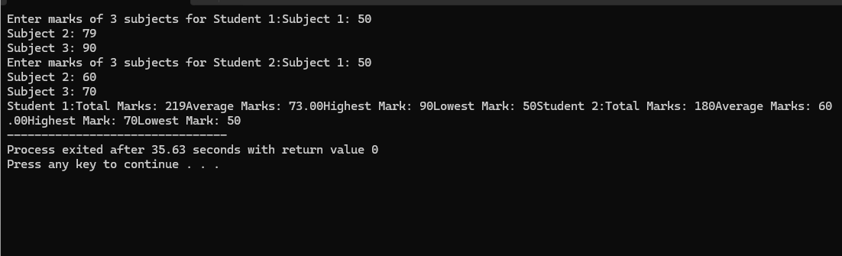

2.
[1:19 pm, 04/10/2025] ABI: #include <stdio.h>

int main() {
int a[3][3], b[3][3], sum[3][3];
printf("Enter elements of first 3x3 matrix:
");
for(int i=0;i<3;i++)
for(int j=0;j<3;j++)
scanf("%d", &a[i][j]);

printf("Enter elements of second 3x3 matrix:
");
for(int i=0;i<3;i++)
for(int j=0;j<3;j++)
scanf("%d", &b[i][j]);

for(int i=0;i<3;i++)
for(int j=0;j<3;j++)
sum[i][j] = a[i][j] + b[i][j];

printf("Resultant Matrix:
");
for(int i=0;i<3;i++) {
for(int j=0;j<3;j++)
printf("%d\t", sum[i][j]);
printf("
");
}
return 0;
}
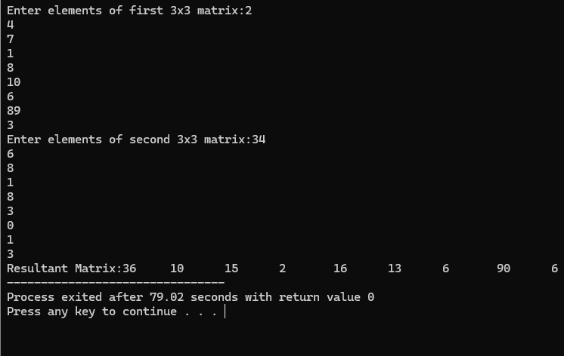

3.
#include <stdio.h>

int main() {
float basic[5], gross[5];
printf("Enter the Basic Salary of 5 employees:
");
for(int i=0;i<5;i++) {
scanf("%f", &basic[i]);
gross[i] = basic[i] + 0.25 * basic[i] + 0.15 * basic[i] + 0.05 * basic[i];
}

printf("
Basic Salary and Gross Salary:
");
for(int i=0;i<5;i++)
printf("Employee %d: Basic = %.2f, Gross = %.2f
", i+1, basic[i], gross[i]);

float high = gross[0], low = gross[0];
for(int i=1;i<5;i++) {
if(gross[i] > high) high = gross[i];
if(gross[i] < low) low = gross[i];
}

printf("
Highest Gross Salary = %.2f
Lowest Gross Salary = %.2f
", high, low);
return 0;
}

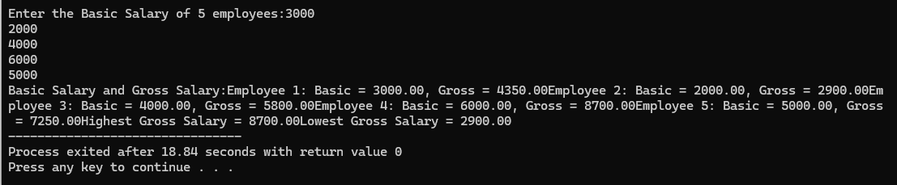

4.
#include <stdio.h>

#define STUDENTS 2
#define SUBJECTS 3

int main() {
int marks[STUDENTS][SUBJECTS];
int totalMarks[STUDENTS] = {0};
float averageMarks[STUDENTS];
int highestMarks = 0, highestStudent = 0;

// Input marks for each student
for (int i = 0; i < STUDENTS; i++) {
printf("Enter marks for Student %d in %d subjects:\n", i + 1, SUBJECTS);
for (int j = 0; j < SUBJECTS; j++) {
printf("Subject %d: ", j + 1);
if (scanf("%d", &marks[i][j]) != 1 || marks[i][j] < 0 || marks[i][j] > 100) {
printf("Invalid input. Please enter marks between 0 and 100.\n");
return 1;
}
totalMarks[i] += marks[i][j];
}
averageMarks[i] = totalMarks[i] / (float)SUBJECTS;

// Check for highest marks
if (totalMarks[i] > highestMarks) {
highestMarks = totalMarks[i];
highestStudent = i + 1;
}
}

// Display total and average marks for each student
printf("\n--- Results ---\n");
for (int i = 0; i < STUDENTS; i++) {
printf("Student %d:\n", i + 1);
printf(" Total Marks: %d\n", totalMarks[i]);
printf(" Average Marks: %.2f\n", averageMarks[i]);
}

// Display the student with the highest marks
printf("\nStudent %d has the highest total marks: %d\n", highestStudent, highestMarks);

return 0;
}

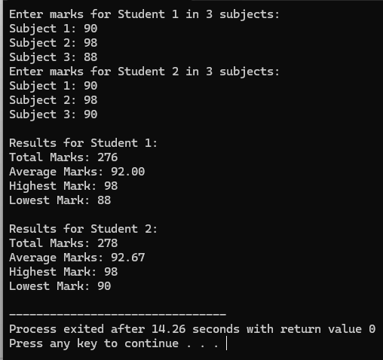

5.
#include <stdio.h>

#define STUDENTS 5
#define SUBJECTS 3

int main() {
int marks[STUDENTS][SUBJECTS];
int i, j;

printf("Enter marks for %d students in %d subjects:\n", STUDENTS, SUBJECTS);
for (i = 0; i < STUDENTS; i++) {
printf("Student %d:\n", i + 1);
for (j = 0; j < SUBJECTS; j++) {
printf(" Subject %d: ", j + 1);
scanf("%d", &marks[i][j]);
}
}

printf("\nStudent Report Card:\n");
for (i = 0; i < STUDENTS; i++) {
int total_marks = 0;
float average_marks;
char grade;

for (j = 0; j < SUBJECTS; j++) {
total_marks += marks[i][j];
}

average_marks = (float)total_marks / SUBJECTS;

if (average_marks >= 90) {
grade = 'A';
} else if (average_marks >= 75) {
grade = 'B';
} else if (average_marks >= 50) {
grade = 'C';
} else {
grade = 'D';
}

printf("Student %d:\n", i + 1);
printf(" Total Marks: %d\n", total_marks);
printf(" Average Marks: %.2f\n", average_marks);
printf(" Grade: %c\n", grade);
}

return 0;
}
